Product Feed PAPI → Azure Migration Guide

Purpose & scope
This guide gives a developer what they need to re-platform three file-movement flows from the product-feed-papi MuleSoft application to Azure.
- In scope: ICON stock files, GMC Google online feed, GMC local inventory feed.
- Out of scope for now: the app's other flows (Adobe classification, Bloomreach transfer, Stibo → MQ, reprocessing) and the SFTP connection details.
- Target pattern: a timer Azure Function that invokes a parameterised Synapse pipeline (source, destination, connection, filename) to move each file.
- Source of truth: the project's src/main/mule flows, global-config.xml and config-<env>.yaml (Mule 4.4.0, CloudHub).

The current application
product-feed-papi is an API-led Process API that moves product-feed files between SAP Commerce Cloud (Hybris) Azure Blob storage and downstream systems.
- Runtime: Mule 4.4.0 on CloudHub (uk-e1).
- Orchestration only: it holds no Blob or SFTP connector of its own — every external touch is an HTTPS call to a dedicated System API (SAPI).
- Scheduler-driven: no inbound traffic except a /status health check, all work is timed.
- Stateless: read a file, optionally rename, deliver, then archive or delete. No database.

The three flows at a glance
Flow | Trigger | Source | Destination | Purpose
ICON stock files | Every 15 min, 07:00–00:00 | ICON ERP (SFTP) | Azure Blob | Pull stock / price / tally files, rename, land in Blob
GMC Google online | 08:00, every 30 min | Azure Blob | GMC (+ Rakuten for jewson) | Deliver per-brand online product feeds
GMC local inventory | Daily 09:00 | Azure Blob | GMC | Deliver per-brand local-inventory feeds

ICON stock files
Pulls stock, price and tally files from ICON over SFTP and lands them, renamed, in Azure Blob.
Property | Detail
Source | ICON ERP over SFTP — /k8data/<env>/Mule/OUT/Hybris/ (qa02, qa03 in test)
Destination | Azure Blob — container hybris, subfolder hot-folder
File selection | List the folder; keep only names matching the stock / price / tally patterns (Term-*WEBNAT, HybStk / HybTal, products-, assets.master)
Rename | Yes — rule-based (see Appendix)
Content transform | None — CSV read then written unchanged, same columns
After move | Move the source file on SFTP to Collected/ on success, error/ on failure

GMC Google online feed
Delivers each brand's Google online product feed from Blob to Google Merchant Center; Jewson's feed also goes to Rakuten.
Property | Detail
Source | Azure Blob — container hybris, subfolder export, prefix export/<brand>_google-online-products-feed_
Brands | gibbsanddandy, jewson, georgeboyd
Destination | GMC; also Rakuten when brand = jewson
File selection | List blobs for the brand prefix, validate filenames
Rename | Delivered file unchanged; error-archive copy keeps the name
Content transform | None — delivered as application/octet-stream (raw bytes)
After move | On failure, copy the file to the Blob error folder, then delete the source blob

GMC local inventory feed
Delivers each brand's local-inventory feed from Blob to Google Merchant Center. Same shape as F2, without the Rakuten leg.
Property | Detail
Source | Azure Blob — subfolder export, prefix export/<brand>-local-inventory-feed-full.txt
Brands | gibbsanddandy, jewson, georgeboyd
Destination | GMC
File selection | List blobs for the brand prefix, validate filenames
Rename | Delivered file unchanged; error-archive copy renamed to <name>_<yyyyMMddhhmmss>.txt
Content transform | None — application/octet-stream passthrough
After move | Conditional error-folder copy, then delete the source blob

Move, not transform
All three flows are file movement. None changes the file's content.
- The body is passed through byte-for-byte — GMC and Rakuten as octet-stream; ICON as CSV in, CSV out with the same columns.
- The only logic is metadata: which files to pick up (filter / validate), what to rename them (F4), which destination to use, and where to archive the source.
- Implication: a plain copy activity carries the bytes; only the metadata logic needs to be written as code.

Target design: timer Function → Synapse
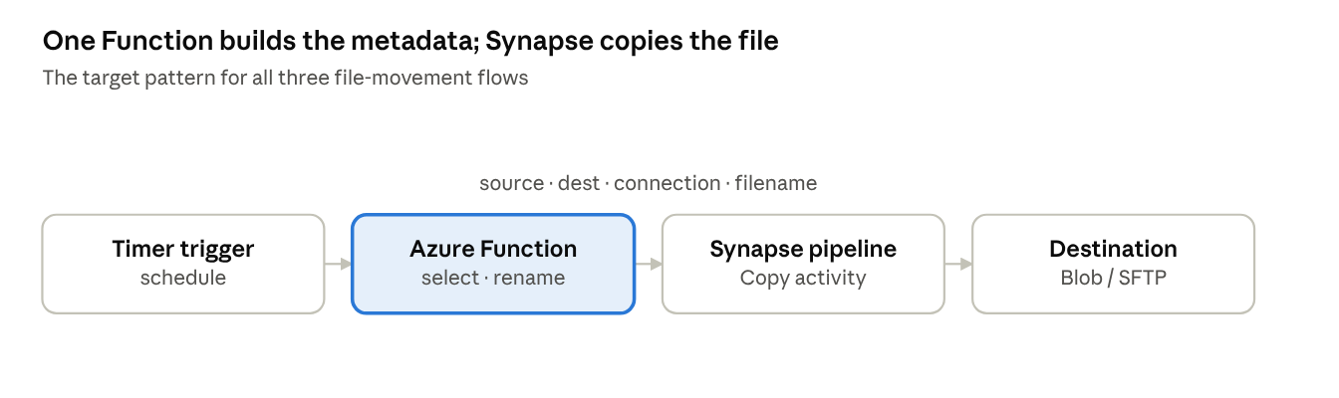
target pattern · timer Function → Synapse Copy
The timer Function lists the source, selects and (for ICON) renames the files, then passes the metadata to a parameterised Synapse Copy pipeline, which moves the bytes and archives or deletes the source.

Mapping each flow to the pattern
One generic, parameterised Synapse copy pipeline serves all three. Each flow's timer Function supplies different metadata.
ICON stock files: SFTP → Blob, move + rename
- Function: list the SFTP folder, apply the regex filter, compute the renamed filename, emit {source SFTP path + file, dest Blob container / folder, new fileName}.
- Synapse: copy SFTP → Blob with a parameterised sink filename; then archive the source (Collected/ or error/).
GMC Google online : Blob → GMC (+ Rakuten), pure move
- Function: loop brands, list blobs by prefix, validate names; per file emit {source Blob prefix + name, destination GMC, fileName}; emit a second invocation to Rakuten when brand = jewson.
- Synapse: copy Blob → GMC (and Rakuten); on failure copy to the error container; delete the source blob.
GMC local inventory : Blob → GMC, pure move
- Function: loop brands, list blobs by prefix, validate names; per file emit {source, destination GMC, fileName}.
- Synapse: identical copy pipeline to F2; conditional error archive; delete the source blob.

Destination protocol: GMC & Rakuten
The GMC and Rakuten destinations are SFTP servers. Use Synapse pipeline for file movement.

Appendix - rename rules & key config
Filename rename rules (source pattern → delivered name):
Source file | Renamed to
products-<14 digits>.csv | products.master-<14 digits>.csv
HybStk_<14 digits>_<branch>.csv | stock.master-<ts>-<branch>.csv
HybStk_<14 digits>_Delta.csv | stock.master-<ts>.csv
Term-GDWEBNAT-<ts>.csv | prices.gibbsd-<ts>.csv
Term-GBWEBNAT-<ts>.csv | prices.georgeboyd-<ts>.csv
Term-IWEBNAT-<ts>.csv | prices.minster-<ts>.csv
Term-JWEBNAT-<ts>.csv | prices.jewson-<ts>.csv
Term-GWEBNAT-<ts>.csv | prices.graham-<ts>.csv
HybTal_<14 digits>_Full / Delta.csv | tallies.master-<ts>.csv
assets.master[-FULL]-<dates>.csv | unchanged
Key config (test):
Setting | Value
Blob container | hybris
ICON → Blob subfolder | hot-folder
GMC source subfolder / prefix | export / export/<brand>...
Brands | gibbsanddandy, jewson, georgeboyd
F4 schedule | every 15 min, 07:00–00:00
F2 schedule | 08:00, every 30 min
F3 schedule | daily 09:00

